Lakewood Library
6th Six Weeks
2018-19
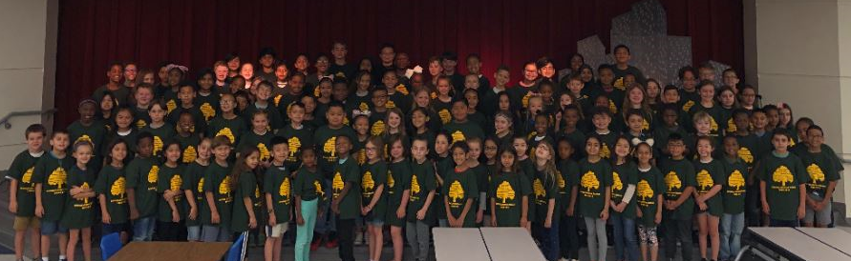

By the numbers:
2,736 Books circulated
182 Books weeded
142 Books added

Lessons-
Kindergarten- Frogs/Counting, Monsters/Rhyming, Fish/Undersea life/Swimmy Bottles
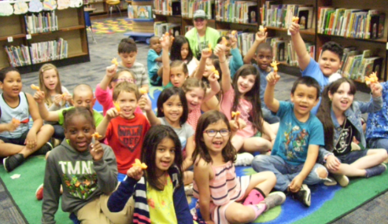
First- Elmer the Elephant, Goodbye Goldfish
Second- The Doorbell Rang/Division,
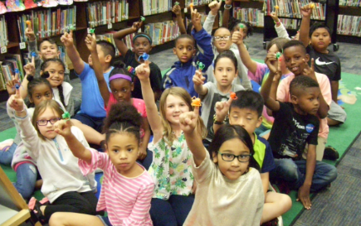
SRI, Goodbye- Monsters
Third Grade- SRI, Goodbye-Stars
Fourth Grade- SRI, Goodbye-Friendship
Fifth Grade- Theme/Mood/Fantastic Flying Books of Morris Lessmore, SRI, Goodbye- Fortune Fish
Sixth Grade- Theme/Mood/Morris Lessmore, SRI, Goodbye-Rocks
Makerspace open 6 hours- 98 visitors
Open Checkout visitors- 130

Library Closed 3 days for STAAR, 1 day for Field Day

What Else?

Worked HEB Reads all of the day, handing out books-
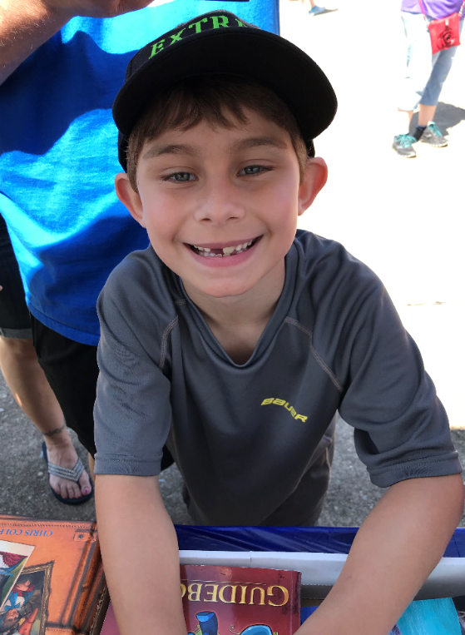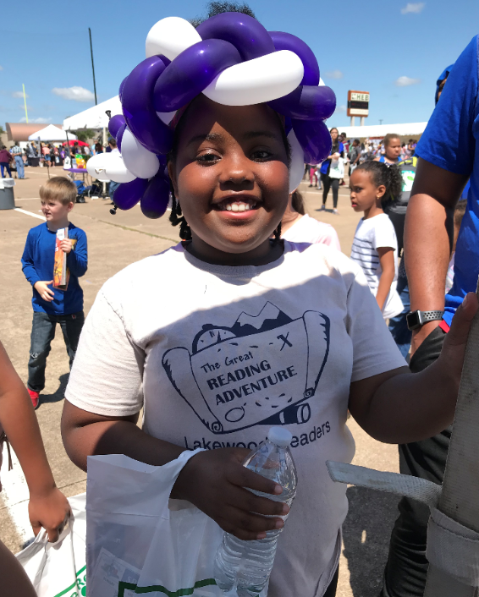

Held Reader’s Celebration for 171 Above and Beyond Readers
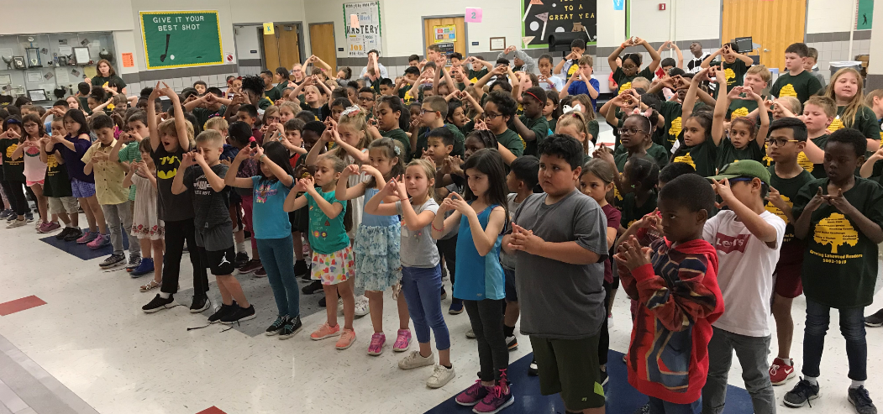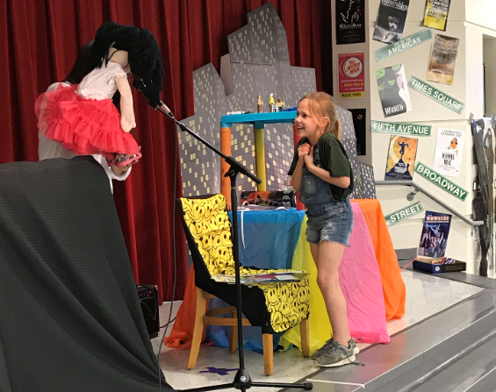

Handed out Summer Success Books to students in Kindergarten-5th Grade
